Welcome

It is our greatest pleasure to welcome you to the International Conference on Science Education 2012 (Nanjing, China) Conference. The ICSE2012 conference is co-organized by the National Association for Science Education the Chinese Society of Education (CNASE) and the Institute of Education of Nanjing University.

At the age of globalization, different countries have paid more attention to learn from each other to develop human talents in science and technology as well as improve citizen’s scientific literacy. Because of differences in culture and tradition between the western and eastern worlds, there have been many challenges when implementing the heavily western influenced science education theories and practices in China and other Asian countries with Confucian culture tradition. This also leads to reflection of western science education tradition. We hope the ICSE2012 (Nanjing) conference can be a good platform for international science education scholars to share their ideas, experiences, strategies to address science education challenges; further, we hope through academic exchange we can foster the development of new ideas with eastern cultural flavor to contribute a unique perspective to the advancement of international science education research to inform both theories and practices.

Science education research is vital in the development of national science education policies, including standards, teacher professional development and public understanding of science. Science education researchers study the quality, feasibility, and alignment of standards at different levels with regard to curriculum materials, assessment practices, and science teacher certification requirements; they also seek ways to bridge formal and informal science education. Science education research thus affects a nation’s ability to fulfill its social responsibilities. Therefore, the ICSE 2012 conference welcomes science education researchers from around the world to exchange experiences, challenges, and strategies in science education research around the above stated areas. These are around a common theme of ‘Science Education: Policies and Social Responsibilities’.

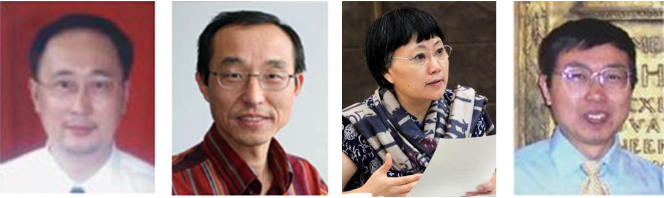

Professors Shujin Peng and Xiufeng Liu

Co-Chairs, ICSE2012 International Organizing Committee

Professors Hongshia Zhang and Baohui Zhang

Co-Chairs, ICSE2012 Local Organizing Committee

Organization

**Organizers**

National Association for Science Education the Chinese Society of Education (CNASE)

Institute of Education, Nanjing University

**Co-organizers**

Institute of Chemistry Education, Beijing Normal University

Center for Teacher Professional Ability Development, Shaanxi Normal University

China Research Institute for Science Popularization

Center for School Curriculum Research & Development Research, Institute of Science Education, Guangxi Normal University

**Sponsors**

Shandong Yuanda Net & Multimedia Ltd.

Springer-Verlag

Popular Science Press

China Science and Technology Press

**About the Chinese Science Education Association**

The Chinese National Association for Science Education (中国教育学会科学教育分会, CNASE, http://www.cnase.org/) is a branch of the Chinese Society of Education (CSE). The Chinese Society of Education (CSE, http://www.cse.edu.cn) was founded on April 12, 1979. It is the first and largest national organization for mass educational academic affairs. CSE has 49 branches. The CNASE, as one of the branches, was founded in November 2009. It has three sub-committees at K-6, G7-12, and college levels, respectively. This is the national association of Chinese science educators, science education researchers, and other related scholars and administrators.

**About Nanjing University**

Nanjing University (http://www.nju.edu.cn) is one of the oldest and most prestigious institutions of higher learning in China. On May 20, 2012, the university has celebrated its 110th anniversary. In 2011, QS World University Rankings ranked Nanjing University 186th overall in the world. It is one of China’s key comprehensive universities under the direct supervision of the Ministry of Education. It dates from 1902 when it was known as Sanjiang Normal School. Today`s NJU consists of three beautiful campuses, Gulou, Pukou, and Xianlin.

**About the Institute of Education, Nanjing University**

The Institute of Education of Nanjing University (http://edu.nju.edu.cn) was set up at the end of 2009. It was built up on the bases of earlier Institute of Higher Education (1984-2002), and later Department of Educational Sciences and Administration (2002-2009), let alone its ancestor dated back as early as to the founding period of Nanjing University at the beginning of the 20th century. Currently, there are 19 staff members in this institute; among them are 17 full time academic faculties. Research areas and interests of the faculty include education administration and policies, curriculum and instruction studies at both K-12 and college levels, educational technology and learning sciences, educational sociology (especially regarding educational equity), student learning and development, cross-cultural studies in educational internationalization, history of education, and science education. There are four M.A. programs, two Ph.D. programs and one Ed. D. Program in this institute. The total enrolment of research students is around 130. The Institute of Education also hosts an academic quarterly journal: Higher Education Exploration and Research (in Chinese).

Conference Organization

**International Organizing Committee**

**Prof. Shujin Peng, Co-Chair**

Vice-President, National Association for Science Education, the Chinese Society of Education (CNASE), China

**Prof. Xiufeng Liu, Co-Chair**

State University of New York at Buffalo, USA

**Prof. Young-Shin Park**, Chosun University, Korea;

**Prof. Takuya Matsuura**, Hiroshima University, Japan;

**Prof. Subramaniam Ramanathan**, Nanyang Technological University, Singapore;

**Dr. Gavin Fulmer**, National Institute of Education, Singapore;

**Prof. Bilal Gunes**, Gazi University, Turkey;

**Dr. Mustafa Sozbilir**, Ataturk University, Turkey;

**Prof. Sibel. Erduran**, University of Bristol, UK;

**Dr. Anil Banerjee**, Columbus State University, USA (India);

**Prof. Alexander Fishman**, Kazan State University, Russia;

**Prof. David Treagust**, Curtin University, Australia;

**Dr. Ling L. Liang**, La Salle University, USA;

**Prof. Lilia Halim**, National University of Malaysia, Malaysia;

**Dr. Rasool Abdullah Mirzaie**, Shahid Rajaee Teacher Training University, Iran;

**Ms. Beverley Cooper**, the University of Waikato, New Zealand;

**Dr. Alyas Qadeer Tahir**, Director, National Institute of Science and Technical Education, Islamabad, Pakistan;

**Prof. Christiane Gioppo**, Universidade Federal do Parana (UFPR), Regional Representative for Latin America, ICASE, Brazil;

**Dr. Ben Akpan**, International Council of Associations for Science Education （ICASE） president, Nigeria;

**Prof. Winnie So**, Hong Kong Institute of Education, Hong Kong;

**Prof. Hsin-Kai Wu**, National Taiwan Normal University, Taiwan;

**Prof. Mei-Hung Chiu**, National Taiwan Normal University, Taiwan;

**Prof. Bing Wei**, Macau University, Macau;

**Prof. Lingbiao Gao**, South China Normal University, China;

**Prof. Xingkai Luo**, Guangxi Normal University, China;

**Prof. Zuhao Wang**, East China Normal University, China;

**Prof. Lei Wang**, Beijing Normal University, China;

**Prof. Bing Liu**, Tsinghua University, China;

**Prof. Weiping Hu**, Shaanxi Normal University, China;

**Prof. Xinning Peng**, East China Normal University, China;

**Prof. Junming Wu**, Shanghai Normal University, China;

**Prof. Boqin Liao**, Southwest University, China;

**Prof. Changchun Lin**, Chongqing Normal University, China;

**Prof. Yi Bai**, Southeast University, China;

**Mr. Jianzhong Zhou**, Southeast University, China;

**Prof. Hua Xiang**, Beijing Normal University, China;

**Dr. Haiwang Huang**, People's Education Press;

**Prof. Rui Wei**, Beijing Normal University, China;

**Prof. Zhen Lu**, Nanjing Normal University, China;

**Prof. Qiyong Cai**, YangtZe Normal University, China;

**Ms. Linghong Meng**, Beijing Institute of Education, China;

**Mr. Xiangdong Wu**, South China Normal University Affiliated Elementary School, China;

**Mr. Xinqi Lu**, National Association for Science Education the Chinese Society of Education (CNASE), China;

**Ms. Ling Chen**, China Research Institute for Science Popularization, China;

**Mr. Dongsheng Wan**, Nanjing University;

**Dr. Ying Tao,** West Australian University, Australia;

**Ms. Yin Zhang**, Guangxi Normal University

**Local Organizing Committee**

**Prof. Hongshia Zhang**, Co-Chair

Dean, Institute of Education, Nanjing University, China

**Prof. Baohui Zhang**, Co-Chair

Institute of Education, Nanjing University, China

**Ms. Mao Cai**, National Association for Science Education (NASE), China **Dr. Yonggui Jiang**

Hanzhou Normal University, China

**Dr. Yonggui Liu**, Institute of Education, Nanjing University, China

**Dr. Xiaohua Zong**, Institute of Education, Nanjing University, China

**Ms. Ying Wang**, Institute of Education, Nanjing University, China

**Mr. Jinlei Zhang**

Institute of Education, Nanjing University, China

**Mr. Leming Liang**, Institute of Education, Nanjing University, China

**English Proceeding Editing Committee**

**Prof. Baohui Zhang**, Institute of Education, Nanjing University, China

**Prof. Xiufeng Liu**, State University of New York at Buffalo, USA

**Prof. Weiping Hu**, Shaanxi Normal University, China

**Dr. Gavin Fulmer**, National Institute of Education, Singapore

**Dr. Yin Tao**, Western Australia University, Australia

**Prof. Shujin Peng**, National Association for Science Education, China

Keynote Speakers

**Prof. Sharon Lynch**

George Washington University, USA, and president of NARST

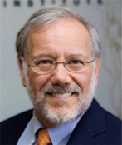

**Prof. Joseph Krajcik**

Michigan State University, USA

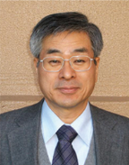

**Prof. Shigeki Kadoya,** National Institute for Educational Policy Research, Japan

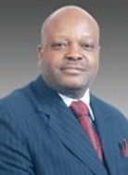

**Dr. Ben Akpan**President, International Council of Associations for Science Education

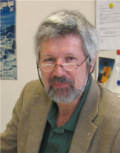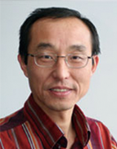

**Prof. Xiufeng Liu**

State University of New York at Buffalo, USA

**Peter Nentwig** University of Kiel,

Germany (IPN)

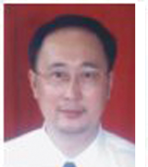

**Prof. Shujin Peng**

Vice-President,National Association for Science Education, the Chinese Society of Education (CNASE), China

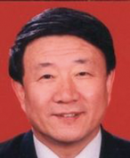

**Prof. Zuoshu Wang**

President, Capital Normal University, the Chinese Association for Non-Governmental Education

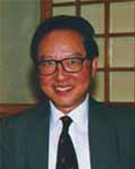

**Prof. Cho-Yee To**

Chinese Hong Kong University, China and University of Michigan, USA

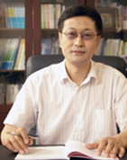

**Prof. Fujun Ren**Director, China Research Institute for Science Popularization, China

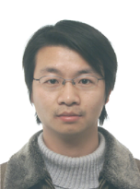

**Prof. Dongchuan Yu**

Director, Key Laboratory of Child Development and Learning Science, Ministry of Education, Southeast University, China

**Prof. Zhang Hongshia**Dean, Institute of education, Nanjing University

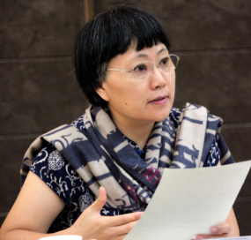  
­

Conference Program

|  |  |  |  |
| --- | --- | --- | --- |
| Oct. 12, 2012，Friday NanYuan Hotel &Anzhong Hotel (Nanjing University, Gulou Campus) | | | |
| 9:00--23:00 | Registration | | |
| Oct. 13, 2012, Saturday YiFu Building-1:Lecture Hall | | | |
|  | Presider: Prof. Hongshia Zhang | | |
| 8:30--9:00 | Greetings and welcome speeches--leaders from Ministry of Education,  Dept. of Education, Jiangsu Province, and Nanjing University | | |
| 9:00--9:15 | Conference Overview (Prof. Baohui Zhang) | | |
| Presider: Xiufeng Liu | | | |
| 9:15--10:00 | Inclusive STEM High Schools: Improving Educational Opportunity and the Economy | Prof.  Sharon Lynch | George Washington University, USA |
| 10:00--10:30 | Photo-taking(Presider: Dr. Yonggui Liu) in front of main entrance of Yifu Building  Tea-break | | |
| 10:30--11:15 | Science Education Policies in China (*Temporary title, In Chinese*) | Prof.  Zuoshu Wang | Capital Normal University, China |
| 11:15--12:00 | Implications of the K -12 Science Education Framework and Next Generation of Science Standards for Teaching and Learning | Prof.  Joseph Krajcik | Michigan State University, USA |
| 12:10--13:50 | Lunch(Xiyuan Restaurant) | | |
| Oct. 13, 2012, Saturday YiFu Building-1:Lecture Hall | | | |
| Presider: Shujin Peng | | | |
| 13:50--14:35 | Training for Science Teachers in Primary and Middle School and the Development of Science Education Profession in China | Prof.  Shujin Peng | Sichuan Normal University, China |
| 14:35--15:20 | An Overview of Science and Technology Education in Nigeria | Dr. Ben Akpan | International Council of Association for Science Education |
| 15:20--16:05 | The Scientific Quality Situation and Development Tendency of Chinese Citizens | Prof.  Fujun Ren | China Research Institute for Science Popularization |
| 16:05--16:20 | Tea-break | | |
| Presider: Changchun Lin | | | |
| 16:20--17:05 | The Development, Implementation and Evaluation of Science Education Standards in Germany | Mr. Peter Nentwig | University of Kiel Germany |
| 17:05--17:50 | IAP-IBSE and Assessment in Science Education | Prof. Dongchuan Yu | Southeast University, China |
| 17:50--18:35 | How to Enhance the Quality of Science Lesson in Japan? | Prof. Shigeki Kadoya | National Institute Educational Policy Research, Japan |
| 18:35--20:00 | Dinner(Xiyuan Restaurant) | | |

|  |  |  |  |
| --- | --- | --- | --- |
| Oct. 14, 2012, Sunday Location: Fei YiMin Building A-318 | | | |
| Presider: Prof. Weiping Hu | | | |
| 8:30--9:15 | Preservice Science Teacher Education: What Can China and the US Learn from Each Other? | Prof.  Xiufeng Liu | State University of New York at Buffalo, USA |
| 9:15--9:45 | Public Science, Science Education, and Citizen Science Literacy *(In Chinese)* | Prof.  Choyee To | Chinese University of Hong Kong |
| 9:45--10:15 | Reaffirmation and Modification of Dewey’s Philosophy of Education for the Globalized Era | Prof.  Hongshia Zhang | Nanjing University, China |
| 10:15-10:30 | Tea-break | | |
| **Concurrent Session (Part I): 10:15--12:30** | | | |
| **Session 1:Posters**  **Location: Fei Yimin Building A-318** | | | |
| Presider: Dr. Yongjun Ma | | | |
| 10:30--12:30 | Posters (14+) | | |
| **Session 2:(Theme) Science Education Curriculum Standards**  **Location: Fei Yimin Building A-310** | | | |
| Presider: Prof. Dongchuan Yu | | | |
| 10:30--11:00 | Stability and Trends in High School Chemistry Curriculum Standards: By Comparison of International Curriculum Standards | Lei Wang,  Mingchun Huang | Beijing Normal University |
| 11:00--11:30 | An Exemplary Study of Processes Establishing and Practicing National Science Education Policy | Sung-Jae Pak | Seoul National University, Republic of Korea |
| 11:30--12:00 | Representations of Nature of Science in Selected Histories of Science in the Integrated Science Textbooks in China | Bing Wei | University of Macau |
| 12:00--12:30 | Examining the Impact of Globalization at the Macro, Meso, and Micro Levels: Employing Intersectionality and Cultural Sociology to Understand the Impact of Immigration on  K -12 Science Teaching and Learning in the USA | Sonya N. Martin | Seoul National University, Republic of Korea |
| **Session 3:(Theme) Public Science Education**  **Location: Fei Yimin Building A-305** | | | |
| Presider: Prof. Fujun Ren | | | |
| 10:30--11:00 | Evaluative Thinking in the Building of Learning Society | Nian Zheng,  Limei Zhang,  Huijun Zhang | China Research Institute for Science Popularization |
| 11:00--11:30 | Structure of the Student Interest in Science and Scientific Literacy: Using the Latent Class Analysis | Takuya Matsuura | Hiroshima University, Japan |
| 11:30--12:00 | Exploring the primary and middle school students’ senses on science and technology based the survey information for the sixth edition 100,000 Whys  (In Chinese) | Keping Sun,  Xiaoli Deng | Shanghai Normal University |
| 12:00--12:30 | Search for SEAMEO Young Scientists (SSYS) –RECSAMs Initiative in Promoting Public Science Education: The Way Forward | Dominador Dizon Mangao | SEAMEO RECSAM, Malaysia |
| **Session 4:(Theme) Science Teacher Education+ Science Education Curriculum Standards**  **Location: Fei Yimin Building A-304** | | | |
| Presider: Prof. Subramaniam Rananathan | | | |
| 10:30--11:00 | Changes from the Curriculum Reform of Basic Education And Teacher Training in China | Boqin Liao | Southwest University |
| 11:00--11:30 | Students’ Perception Concerning Science Teachers’ Pedagogical Content Knowledge | Lilia Halim | Universiti Kebangsaan, Malaysia |
| 11:30--12:00 | Some Approaches in IT Integration in Physics Education (Distance) | A.I. Fishman | Kazan Federal University, Russia |
| 12:00--12:30 | Impact Analysis of Student Centered Inquiry Based Project and its Implications on Standards of Science Curriculum in Pakistan (Distance) | Alyas Qadeer Tahir | National Institute of Science and Technical Education, Pakistan |
| **Session 5: Other Themes**  **Location: Fei Yimin Building A-303** | | | |
| Presider: Prof.Yi Bai | | | |
| 10:30--11:00 | A Research on the Nature of Science Education from the Perspective of Science Rooted in Philosophy (In Chinese) | Guanjie Liu | Zhengzhou Normal University |
| 11:00--11:30 | Laboratory-Based Scaffolding Strategies for Learning School Science | Sau Kheng Au,  Kok Siang TAN | National Institute of Education, Singapore |
| 11:30--12:00 | A Study of Pupils Pose Ill-structured Problem in Knowledge Building Class (In Chinese) | Li Zhang,  Yibing Zhang | Nanjing Normal University |
| 12:00--12:30 | Exploration of High school Students’ Concepts about Climate Change through Issue Concept-map (IC-map) | Kongju Mun | Ewha Womans University, Republic of Korea |
| 12:40--14:00 | Lunch(Xiyuan Restaurant) | | |
| **Concurrent Session (Part II):14:00--16:00** | | | |
| **Session 1:(Theme) Science Education Curriculum Standards**  **Location: Fei Yimin Building A-318** | | | |
| Presider: Dr. Juan Ni | | | |
| 14:00--14:30 | Study on Comparison of the Concept in the Science Textbook between China and Australia (In Chinese) | Hong Cui,  Kunlan Zhao | Central China Normal University |
| 14:30--15:00 | Investigating Current Situation of Science and Technology Education Master Programs in China (In Chinese) | Baohui Zhang,  Jing Zhang | Nanjing University |
| 15:00--15:30 | Scientific literacy, Science Nature and Science Inquiry: the Pursue and its teaching expectations of science curriculum standards in the Compulsory education Stage (In Chinese) | Juan Ni | Jiangsu Education Research Institute |
| 15:30--16:00 | HOS Content Analysis in China Science Textbooks from the Perspective of Enculturation (In Chinese) | Yongjun Ma | Qingdao University |
| **Session 2:(Theme) Public Science Education + Other Themes**  **Location: Fei Yimin Building A-310** | | | |
| Presider: Prof. Zhen Lu | | | |
| 14:00--14:30 | The Remarkable Role of Digital Experiment System in the Area of Science Education: Experiences from NSTA & AAPT 2012  (In Chinese) | Ding Li | R & D Center of Shanghai K-12 Digital Lab System |
| 14:30--15:00 | Problems, Reasons and Solutions on the Cultivation of Science Student Teachers (In Chinese) | Qi Long | Nanjing Xiaozhuang University |
| 15:00--15:30 | On Narrowing the Gap between the Pace of Urbanization and the Progress of Peasants’ Science Literacy (In Chinese) | Dongyun Chen | China Research Institute for Science Popularization |
| 15:30--16:00 |  |  |  |
| **Session 3: Other Themes**  **Location: Fei Yimin Building A-305** | | | |
| Presider: Prof. Sung-Jae Pak | | | |
| 14:00--14:30 | A Cross-Cultural and Cross-Sectional Comparison of Korean, Indonesian, and American Students' Evolutionary Knowledge Growth and Acceptance Change | Minsu Ha | The Ohio State University, U.S. |
| 14:30--15:00 | Students’ Understanding of Light Propagation and Visibility of Objects in Different Contexts: Stable or Unstable Conceptualization | Hye-Eun Chu | Nanyang Technological University, Singapore |
| 15:00--15:30 | The Study of Koreans’ View of Nature  (Distance) | Yumi Lee  Yeon-A Son | Dankook University, Republic of Korea |
| 15:30--16:00 | Suggesting a Flow Map of the Nature of Science based on Kuhn’s Scientific Revolution for Sciences Education (Distance) | Jun-Young Oh | Hanyang University, Republic of Korea |
| **Session 3: Other Themes**  **Location: Fei Yimin Building A-305** | | | |
| Presider: Prof. Bing Wei | | | |
| 14:00--14:30 | An Empirical Study of Influence Factors of Elementary Science Teachers’ Professional Development Level | Xin Shou,  Changchun Lin | Chongqing Normal University |
| 14:30--15:00 | The Development of POCoM (Practical On-site Cooperation Model) for Korean Science Teacher Profession with the approach of PAR (Participatory Action Research) | Young-Shin Park | Chosun University, Republic of Korea |
| 15:00--15:30 | Using Formative Assessment to Develop Pre-service Chemistry Teachers’ Teaching Skills (In Chinese) | Silin Wei | Hangzhou Normal University |
| 15:30--16:00 | A Study on the Effect of Long-Term Student Teaching in Science Education | Koichi Furuya | Hokkaido University of Education, Japan |
| **Session 5:(Theme) Science Education Curriculum Standards + Science Teacher Education**  **Location: Fei Yimin Building A-303** | | | |
| Presider: Prof. Yuanhong Yan | | | |
| 14:00--14:30 | History and Challenges of Integrated Science Curriculum Implementation in Zhejiang | Xiao Huang | Zhejiang Normal University |
| 14:30--15:00 | Comparative study of 2001&2011 Two Edition Junior Middle School Science Curriculum Standard Based on the View of Nature of Science (In Chinese) | Wenfa Yan | Shaanxi Normal University |
| 15:00--15:30 | The Operational Classification of Behavioral Verb in Experiential Target-Taking the Compulsory Education Science Curriculum Standard [2011 Edition]as an Example | Chengyin Yang | Shaanxi Normal University |
| 15:30--16:00 | On the Evolution of a Lesson: Group Preparation for Teaching Contest as Teacher Professional Development Activity for Chinese Elementary Science Teachers | Xiaowei Tang,  Faxian Shao | Southwest University; Chongqing Institute of Educational Science |
| 16:00--16:20 | Tea-break | | |
| **Concurrent Session (Part III):16:20--18:20** | | | |
| **Session 1:(Theme) Science Teacher Education**  **Location: Fei Yimin Building A-318** | | | |
| Presider: Prof. Keping Sun | | | |
| 16:20--16:50 | Discussion on Enhancing Practical Teaching and Promoting Pre-Career Science Teachers' Vocational Skills (In Chinese) | Hong Feng | Chengdu Normal University |
| 16:50--17:20 | Implementing Intercultural Education in Science Teaching  (In Chinese) | Yi Song | Nanjing Xiaozhuang University |
| 17:20--17:50 | Subject Didactics of Science and the Reform of Science Teacher Education Programs: An International and Comparative Perspective (In Chinese) | Bangping Ding, Xiuye Gao | Capital Normal University |
| 17:50--18:20 | Development of an Instrument: Assessing for Effectiveness of Primitive System of Chemistry Classroom Teaching  (In Chinese) | Changlong Zheng, Lihai Fu, Peng He | Northeast Normal University |
| **Session 2:Other Themes**  **Location: Fei Yimin Building** **A310** | | | |
| Presider: Prof. Lilia Halim | | | |
| 16:20--16:50 | Fostering Conceptual Change in Chemistry: Experiences from a Pre-Service Teacher Education Program in Singapore | Subramaniam Rananathan | National Institute of Education, Singapore |
| 16:50--17:20 | Energy Education Curriculum for Children Based on Fostering Creativity in Elementary School | Rasol Abdullah Mirzaie | Shahid Rajaee Teacher Training University , Iran |
| 17:20--17:50 | Argumentation in University Chemistry Education: A Case Study of Practical Investigations from Activity Theory Perspective | Xiaomei Yan | University of Bristol, UK |
| 17:50--18:20 | The International Baccalaureate Diploma Programme Science Courses | David Jones | The International Baccalaureate Organization |
| **Session 3:(Theme) Public Science Education + Other themes**  **Location: Fei Yimin Building** A305 | | | |
| Presider: Dr. Silin Wei | | | |
| 16:20--16:50 | The Tentativeness of Scientific Theory: A Case Study on Views across Different Educational Levels in Malaysia | Jasmine Jain | Universiti Teknologi MARA, Malaysia |
| 16:50--17:20 | Astronomy School-based Curriculum: the Combination of Resource of Science and Technology Museum and formal Science Learning (In Chinese) | Lihui Wang | China Research Institute for Science Popularization |
| 17:20--17:50 | Effect of Different Contexts on Scientific Reasoning: Focusing on the Lower Secondary School Students | Hiroshi Unzai | Hiroshima University, Japan |
| 17:50--18:20 | Analysis of International Science Education Research Progress during 1982-2011: Bibliometrical Study base on SCIE and SSCI (In Chinese) | Yanchao Sun | Anyang Normal University |
| **Session 4:(Theme) Science Teacher Education + Other themes**  **Location: Fei Yimin Building A-304** | | | |
| Presider: Prof. Yibing Zhang | | | |
| 16:20--16:50 | The Major Buildup of Science Education and Science Teachers Cultivation Based on the Concept of Generalist Education: Practice of Science Education of the Last Decade at Taiyuan Normal University (In Chinese) | Yuanhong Yan | Taiyuan Normal University |
| 16:50--17:20 | Research on the Chemistry Teachers’ Professional Development Status in the Northwest China and Its Countermeasures  (In Chinese) | Jiaorong Yang | Shaanxi Normal University |
| 17:20--17:50 | A Survey on Primary Science Teachers’ Understanding of the Nature of Science (In Chinese) | Jing Cao | Chongqing Normal University |
| 17:50--18:20 | Pre-service Science Teachers' Understanding of Scientific Models and Modeling (In Chinese) | Henglu Zhang | Hangzhou Normal University |
| **Session 5:(Theme) Science Education Curriculum Standards**  **Location: Fei Yimin Building A-303** | | | |
| Presider: Junming Wu | | | |
| 16:20--16:50 | An Alignment Study between Science Education Standards and Test Papers of Middle School Leaving Examination  (In Chinese) | Daiping Duan  Guangzhou Li | Nanjing Normal University |
| 16:50--17:20 | The Call to Innovate: Transformed Notions of the Purpose of STEM Education in Australia | Tanya Doyle | James Cook University, Australia |
| 17:20--17:50 | The New Requirements Of the Engineering and Technical Education in The U.S. Science Education | Zhoujing Wei, Yi Bo | Southeast University |
| 17:50--18:20 | A Comparative Research on Connections across Disciplinary Areas in Science Standards between China and America  (In Chinese) | Yanlin Wang | South China Normal University |
| 18:40--20:30 | Dinner (Closing ceremony, Xiyuan Restaurant) | | |

|  |  |
| --- | --- |
| Oct.15, 2012, Monday | |
| 8:30--11:30 | Workshop and Panel Discussions  **Workshop**: Science Education Research and Publication  Organizers: Prof. Xiufeng Liu, Prof. Baohui Zhang  **Panels:**  1. Panel Discussion on Public Science Education  Organizer: Prof. Hongshia Zhang  2. Panel Discussion on Public Science Education  Organizer: Prof. Shujin Peng  3. Panel Discussion on Public Science Education  Organizers: Prof. Sung-Jae Pak, Prof. Baohui Zhang |
| 11:45--14:00 | Lunch(Xiyuan Restaurant) |

Map of NJU

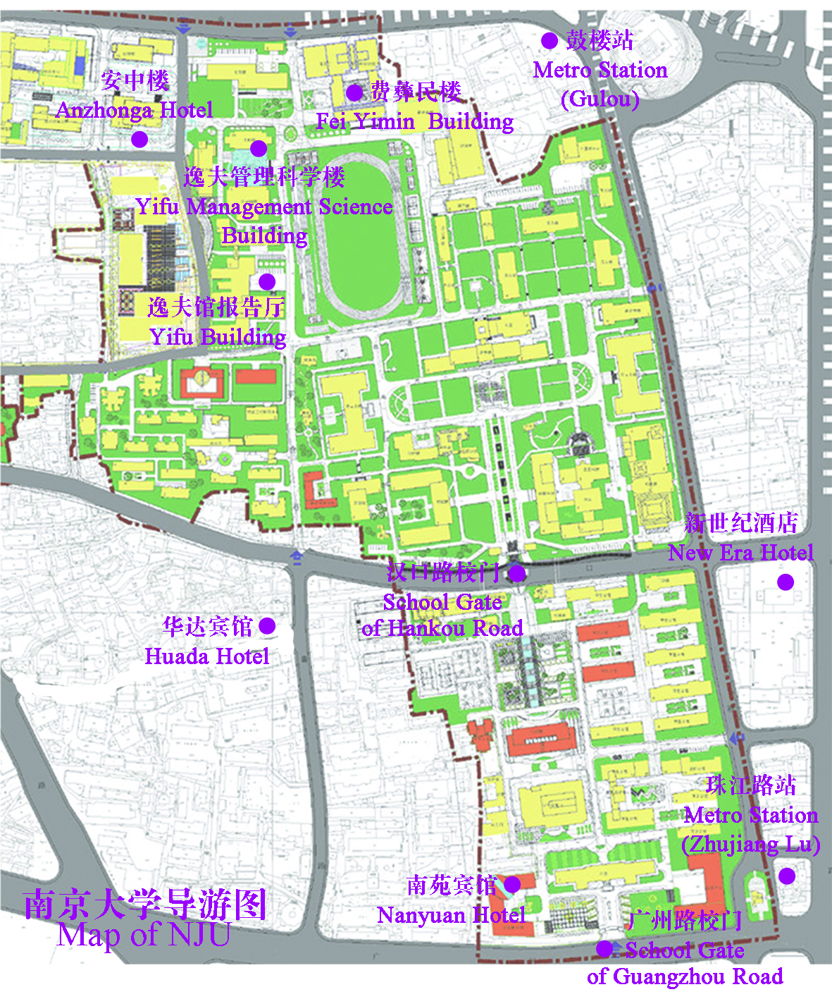

Transportation from Airport to NJU Gulou Campus

**By Airbus Line 2**

Take Airbus Line 2 to Zhonghuamen Station, then take Subway Line 1 to Zhujianglu Station.

**By Taxi**

Costs about 200 RMB and takes about 1.5 hours.

Transportation from Train Station to NJU Gulou Campus

**By Taxi**

From Nanjing Station: Costs about 20 RMB and takes about 15 minutes.

From Nanjing South Station: Costs about 60 RMB and takes about 50 minutes.

**By Subway**

Take Subway Line 1 from Nanjing Station/Nanjing South Station to Zhujianglu Station.

**About Public** **Transportation in Nanjing**

**Taxi in Nanjing**

The taxi driver should start the meter as soon as you are picked up (starting at ¥9). Ask for a printed receipt detailing the taxi number, kilometres travelled, times, and money exchanged from the driver upon exiting the taxi. Tipping is not expected in taxis in China, so the price on the meter is the price you should pay. Please remember to get your hotel's business card and get hotel staff to write down your destination names in Chinese to show your taxi driver before you set off.

**Nanjing Subway System**

The Nanjing Subway System has 2 lines and covers most of the central city. The lines are as follows: *Line 1* runs from Maigaoqiao in the north, via the railway station and along the length of Zhongshan Lu through the city centre to Andemen - from there the line splits with alternate services going to the Olympic New Town area around the Olympic Sports Centre and to the south towards China Pharmaceutical University via the new South High-Speed train station. Services between Maigaoqiao and Andemen run every 3 minutes, and every 6 minutes on each branch line. *Line 2* runs from the new town area in the west and follows Hanzhong Lu and Zhongshan Donglu to the east, terminating nearby the Purple Mountain scenic area. Trains run every 6 to 8 minutes. There are interchanges to Line 1 at Yuantong and Xinjiekou stations. Trains run from approx. 5am to 11pm. Single-journey tokens cost between 2 and 6 yuan depending on distance and can be purchased from vending machines in the station. Stored-value tickets are also available (see above) and give a 5% discount.

**By Bus (Not recommended)**

Most Visited Spots in Nanjing

**Qin Huai River**

One of the most visited spots in Nanjing is the waterside of the Qin Huai River. A preserved historical district, the alleys and willow-covered walkways along the river have been a destination since Tang (618-906) times. During the city's heyday during the Ming Dynasty (1368-1644) the river front was full of pleasure houses for wealthy merchants. Some of Nanjing's best known spots dot the river, including the Confucius Temple and the Imperial Examination Hall Museum.

**Confucius Temple**

One of the best-known landmarks in Nanjing, the Confucius Temple dates back to 1034 and the Song Dynasty. Venerating the great philosopher Confucius, whose teachings are no doubt the most influential in China, the temple became even more significant as Nanjing became the examination sight for Confucian scholars taking the Imperial civil service exam at the nearby Examination Hall.

**Dr. Sun Yat-sen Mausoleum**

This magnificent mausoleum for Dr. Sun Yat-sen (Sun Zhongshan), widely revered as the founder of modern China, has become a mecca for Chinese tourists seeking to pay their respects. Sun Yat-sen died in Beijing in 1925 but wasn't interred here until 1929, when construction of the mausoleum was complete. At the top of the 392-step grand tomb passage, a white marble statue of Dr. Sun sits under the pretty mosaic roof of the Memorial Hall. On the way down, you'll be treated to a nice view of downtown Nanjing and its surroundings.

**Nanjing Museum**

With literally thousands of years of records, the Nanjing Museum is the place to come to swallow a bite-sized amount of historical information or gorge yourself on the expansive selection. Exhibits in Chinese and English span from neolithic times down to the Republican era. Maps, artwork, even a Han-era jade burial suit are among the exhibits. Travelers agree that the Nanjing Museum gives an appreciable overview to Chinese history, culture and art. Repeat visits always reveal something worthwhile.

**Presidential Palace**

The modern facade facing the street with columns and a stately presence is the Republican-era (1927-1949) governmental office of Dr. Sun Yat-sen, China's first president. On display here are Dr. Sun's private quarters as well and wax figures of important moments in Republican history. Further into the complex are exhibits related to the Taiping Rebellion. Xuyuan Garden at the rear of the compound as its own unique history, admission to the Presidential Palace includes the garden. For visitors interested in modern Chinese history, the Presidential Palace is a must see.

**Jiming Temple**

The original Jiming Temple was built at this site in 527. The temple complex has been repeatedly modernized for the last 1500 years. The current layout dates from 1387, however a fire in 1973 gutted most of the complex, which wasn't completely restored until the 1980s. The temple sits along Xuanwu Lake near the ancient City Wall. Visitors can climb to the top of Yaoshi Ta Pagoda for incredible views of the area.

**Purple Mountain (Zijin Shan)**

Named for the mysterious purple-gold clouds that often cover its peaks at dawn and twilight, Zijin Shan is a low rising mountain that dominates the skyline east of downtown Nanjing. The 20 square kilometer (4900 acre) area is rich in monuments to the ancient past, such as the Ming Xiaoling Tomb of Zhu Yangzhang (1328-1398), first emperor of the Ming Dynasty, as well as more recent memorials, such as the Sun Yat-sen Mausoleum (completed 1929). Tourist buses Y1 and Y2 run through the mountains roads. there is also a gondola near Zhongshan Gate that takes passengers up and down to the highest peak. The area is also sometimes called Zhongshan or central mountain.

**Zhanyuan Garden**

This Ming Dynasty (1368-1644) era garden is one of the most famous Chinese gardens in South China. The elaborate walkways, bridges and halls preserve opulence distinct to Ming- and Qing-era China. Peaceful pools center in unusual rockeries to be viewed from distinct pavilions. This garden's highlights vary with the seasons, so it is a year-round attraction. However in the fall the unusually bright yellows and oranges of the foliage will stand out in memory and photographs.

**Ming Xiaoling Mausoleum**

More peaceful than Sun Yat-sen's mausoleum is the tomb of the founder of the Ming dynasty, Zhu Yuanzhang (1328-98),

also known as the Hongwu emperor. The

site has recently been polished up with funds from UNESCO after being deemed a World Heritage Site.

Contact Persons

**Prof. Baohui Zhang**

Tel: +86-189-3689-4289

**Mr. Jinlei Zhang (Coordinator)**

Tel:+86-182-6008-5771

**Mr. Leming Liang (Reception)**

Tel:+86-182-6008-5767

**Ms. Ying Wang (Finance)**

Tel:+86-182-6008-5770

**Ms. Qiaoqiao Cao (Venue Service)**

<Tel:+86-158-9645-4502>

**Ms. Yin Zhang (Accommodation)**

Tel:+86-182-5192-9030

Emergency Service

**Police**  110

**Ambulance**  120

**Fire** 119

Taxi Card

1. Please take me to Nanyuan Hotel(Tel: 86080641), near to Guangzhou Road Gate of Nanjing University.

请带我到南苑宾馆(电话：86080641)，停在南京大学广州路门口。

2. Please take me to New Era Hotel (Tel: 83302777), 251 Zhongshan Road.

请带我去中山路251号的新纪元宾馆(电话：83302777)。

3. Please take me to main entrance (Hankou Road Gate) of Nanjing University.

请带我去南京大学汉口路门。

**Note**

You can clip out Taxi Card from this paper and show it to the taxi driver when you go out.